PACKAGING DAMAGE DETECTION
PROJECT PROPOSAL

1.Project Title:
Damaged vs Intact Package Classification Using Convolutional Neural Networks and Transfer Learning.

2.Background and Motivation:
The rapid growth of e-commerce and logistics industries has increased the need for efficient package inspection systems. Damaged packages can lead to customer dissatisfaction, financial losses, and increased return rates. Traditionally, package inspection is performed manually, which is time-consuming and prone to human error.
Recent advances in computer vision and deep learning provide automated methods for image-based inspection. Convolutional Neural Networks (CNNs) have demonstrated strong performance in image classification tasks by automatically learning visual features from images. Additionally, transfer learning models such as MobileNetV2 can leverage pretrained knowledge to improve classification accuracy.
This project aims to develop an intelligent image classification system capable of distinguishing between damaged and intact packages.

3.Problem Statement
Manual package inspection is inefficient and may fail to detect damaged packages consistently. An automated image classification system is required to accurately identify package conditions from images.
The goal of this project is to classify package images into two categories:
- Damaged Package
- Intact Package
using deep learning techniques.

4.Selected Dataset
Dataset Name:
Damaged and Intact Packages Dataset
Dataset Link:
https://www.kaggle.com/datasets/rahulm7323/damaged-and-intact-packages

5.Dataset Description
The dataset contains images of shipping packages belonging to two classes:
- Damaged Packages
- Intact Packages
The images represent real-world package conditions and are suitable for image classification tasks.

Dataset Characteristics
Number of Classes:
2
Class Names:
- Damaged
- Intact
Image Type:
RGB Color Images (.jpg/.jpeg/.png)
Class Distribution:
Damaged Images: 286
Intact Images: 342
Total Images: 628
The dataset will be resized to 224 × 224 pixels before model training.

6.Research Question
The project aims to answer the following questions:
- Can a CNN accurately classify damaged and intact package images?
- Does transfer learning improve classification performance compared to a custom CNN model?
- Which model achieves better accuracy and generalization capability?
- What types of package images are commonly misclassified?

7.Expected Results
The expected outcomes of this project include:
- Successful classification of package images into damaged and intact categories.
- Validation accuracy above 85%.
- Improved performance using transfer learning compared to a basic CNN model.
- Visual evaluation using confusion matrices, ROC curves, and training curves.

8.Proposed Methodology
Step 1: Data Collection
Load package images from the Kaggle dataset.

Step 2: Data Preprocessing
- Resize images to 224 × 224
- Normalize pixel values to [0,1]
- Handle class labels

Step 3: Data Augmentation
Apply:
- Rotation
- Zoom
- Width shift
- Height shift
- Horizontal flip

Step 4: Dataset Splitting
- Training Set (80%)
- Validation Set (20%)
- Test Set (optional separate evaluation)

Step 5: Model Development
Develop a custom CNN model.

Step 6: Transfer Learning
Implement MobileNetV2 using pretrained ImageNet weights.

Step 7: Model Training
Train both models and compare performance.

Step 8: Model Evaluation
Evaluate models using multiple performance metrics.

9.CNN Model Design
The proposed CNN architecture consists of:
Input Layer (224 × 224 × 3)
↓
Conv2D (32 filters)
↓
MaxPooling2D
↓
Conv2D (64 filters)
↓
MaxPooling2D
↓
Conv2D (128 filters)
↓
MaxPooling2D
↓
Flatten
↓
Dense (128)
↓
Dropout (0.5)
↓
Output Layer (Sigmoid)
The CNN will use:
  - ReLU activation
  - Adam optimizer
  - Binary Cross entropy loss

10. Transfer Learning Model
The project will implement:
MobileNetV2
Features:
• Pretrained on ImageNet
• Feature extraction using frozen convolutional layers
• Custom classification head
The performance of MobileNetV2 will be compared against the custom CNN model.

11.Evaluation Metrics
The following metrics will be used:

Classification Metrics

• Accuracy
• Precision
• Recall
• F1-Score

Visualization Metrics

• Confusion Matrix
• ROC Curve
• AUC Score

Training Metrics
• Training Accuracy
• Validation Accuracy
• Training Loss
• Validation Loss

12. Expected Figures and Tables

Figures:

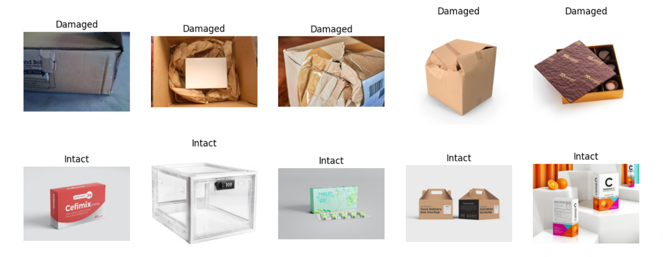
Figure 1: Sample Dataset Images
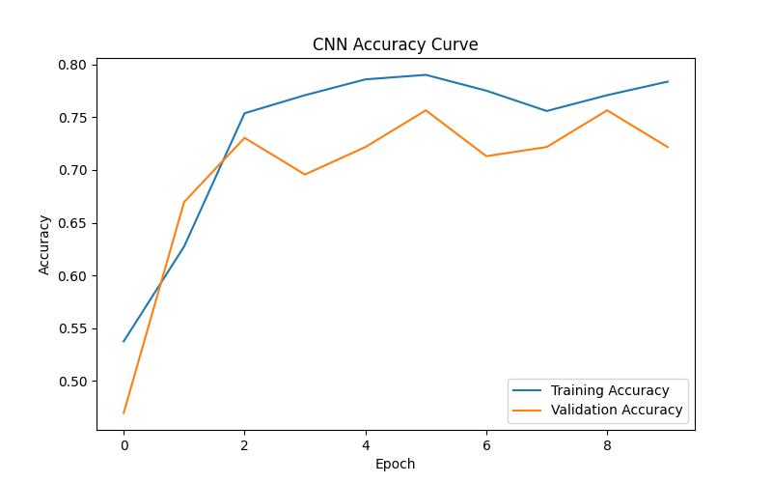Figure 2: CNN Accuracy Curve

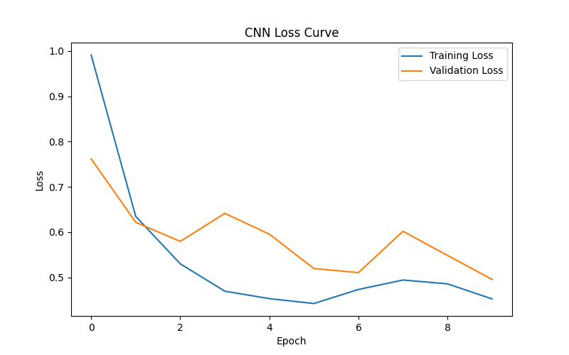
Figure 3: CNN Loss Curve

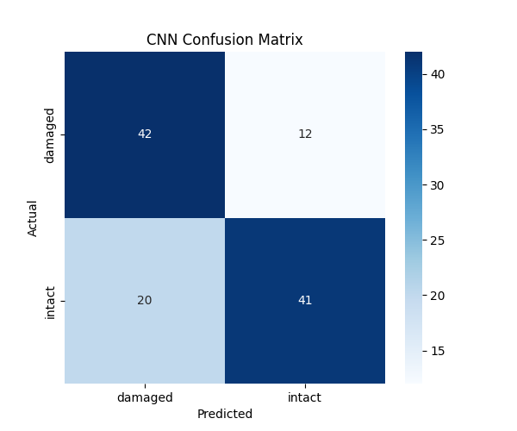
Figure 4: CNN Confusion Matrix

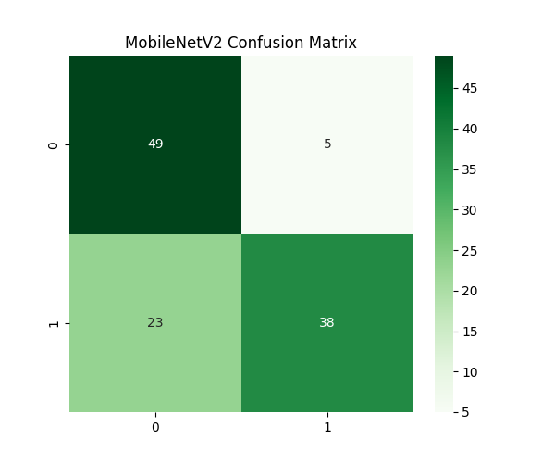
Figure 5: MobileNetV2 Confusion Matrix
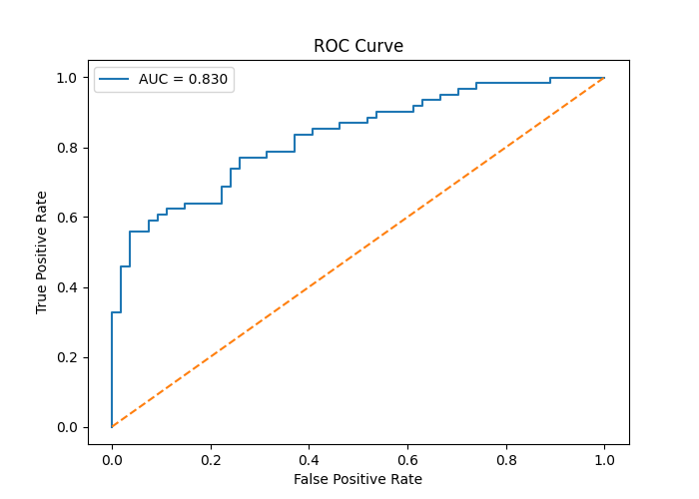
Figure 6: ROC Curve

Tables:

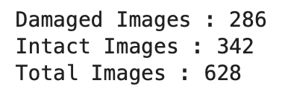
Table 1: Class Distribution
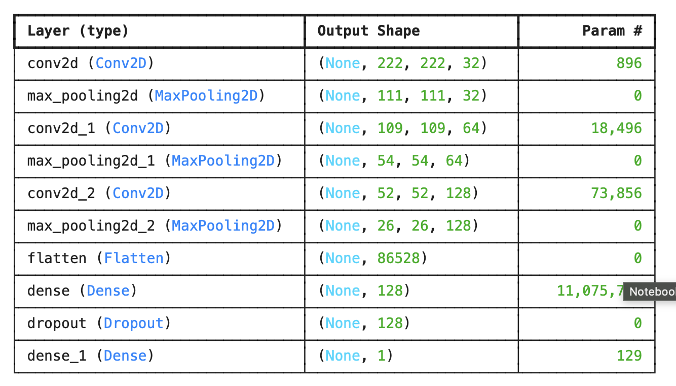
Table 2: CNN Architecture

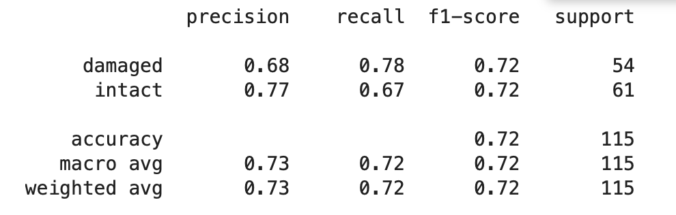
Table 3: CNN Performance Metrics

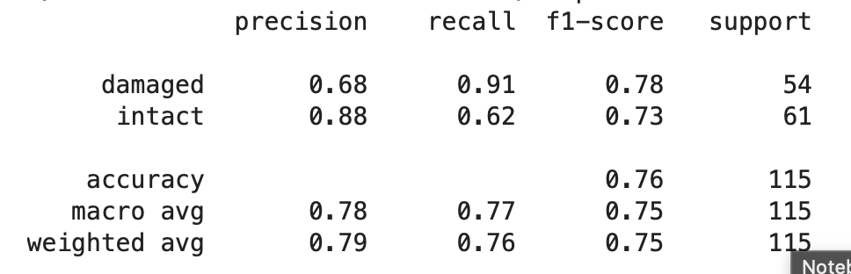
Table 4: MobileNetV2 Performance Metrics

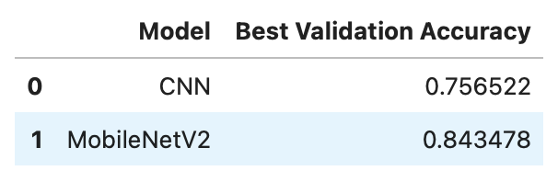
Table 5: Model Comparison Results

13. Conclusion
This project proposes an automated package inspection system using CNN and transfer learning techniques. By comparing a custom CNN model with MobileNetV2, the study aims to identify the most effective approach for detecting damaged packages. The results are expected to demonstrate the usefulness of deep learning in logistics and package quality assessment applications.

